Arts Integration Lesson Plan Idea:
“The Counting Tree”
Teacher: Marlena Murtagh

Grade Level:
- 1st grade learners, but could be adjusted to fit different ages in Elementary school.

Objective:
To create and solve mathematic addition equations with five to seven year olds using fall themed artwork.

Materials:
-Brown paper
-Tape
-Markers
-Crayons
-Leaf cut out shapes, (2) photocopied so each child has 2 “coloring leaves” and 3 “drawing leaves”
-Stapler
- Multi colored construction paper

Prep Work:
1. Before the class period, there are several things that need to be done. Draw a display tree with no leaves. This should be simple “fall tree” shape that looks barren for winter. Mine was about three feet tall by 2 feet wide. You can draw this on large, plain paper and add color. Alternatively, if you do not want to hang up the activity on a bulletin board, you can draw a simple tree on your white or chalkboard or even draw a small, barren tree on a clear overhead and project it.

2. Located below are two different types of leaf shapes. The maple leaf shape is for the kids to draw their own pictures on. The oak leaf is for them to simply color in.

3. You will need enough photocopies in amounts mentioned above. Roughly cut these leaf shapes out… or better yet, use a leaf template!

4. Set out various crayons for the kids and give each one two or three oak leaves to “just color” and three maple leaves to draw pictures on.

5. Write on the board a title and/or description. For example: “Ms. Marlena’s Fall Counting Project”

Sequence of Events:

- Introduce the lesson to the children by explaining that we will combine their artistic skills with their mathematic skills. Lay out ground rules for the activity. (Do not leave seats, we will put away crayons early so that we can do the addition part of the lesson, etc.)

- Explain the leaves: Today we will be drawing on leaves and then adding them together to see how many leaves we have altogether. The Oak leaves, (show example,) you can color however you want. The Maple leaves, (show) you should draw a picture of something you like to do during the season fall. If at this point the students need help thinking of ideas, give an example. Then, have them generate their own ideas by raising hands around the room.

- Tell them to get started artmaking and walk around the room for observation and help. They should color for about 15 minutes. If the children get finished early, give them extra maple leaves to make pictures. This is obviously more creative than just coloring in the lines.

- Clean up time. When finished, sit around the pre-made tree with leaves in hand.

- Once quiet, explain that we will be making math equations out of your leaves. Call on two students to come up to the board/tree. Have the students count their leaves. For example, if Joline has 6 leaves and Derrick has 4, the teacher writes on the board and/or large paper:
6 + 4 = 10
**But, make sure you ask the class each time, “What is six plus four?” Someone with a raised hand will solve the math problem.
Continue doing this by calling on new pairs of students and writing the next equation directly below. Ex:
6 + 4 = 10
3 + 5 = 8 (etc)
You should get different numbers of leaves from each student because some will not finish everything, while some will have extra from you.

- After collecting all of the leaves, place them in a large pile. Using your line of equations, add up the total of leaves. (The teacher will have to do the addition here because they cannot add that many numbers yet.)
- Explain that later in the day, (during a free period,) you will tape/staple the leaves to the tree.
- Going one step further: this project makes a great idea for a bulletin board in the classroom or hallway. It shows both the creativity and intelligence of your students!

Closure:
Ask some questions:
- Do we have a lot of leaves, or a small amount?
- What was your favorite part of the lesson?
- What is your favorite thing to do in the fall?
- Which part did you enjoy better, the addition or the art?

Shapes to Photocopy: Maple Leaf

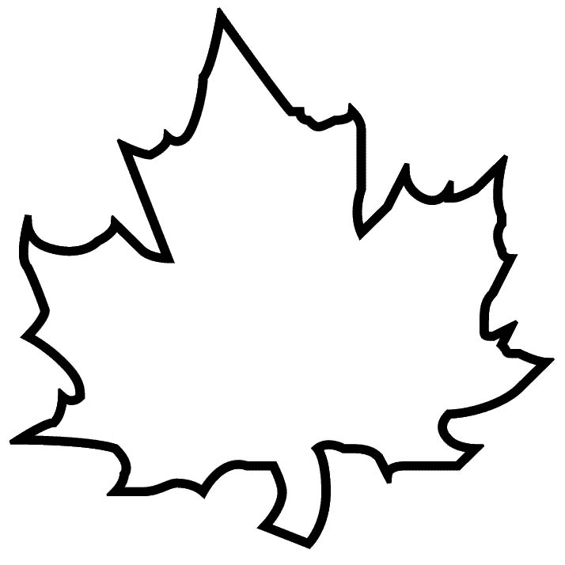

Other Shape to Photocopy: Oak Leaf
